

Molluscum Contagiousum
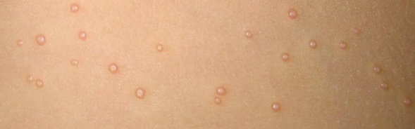
Molluscum Contagiousum is a very common skin infection in children. It is characterized by raised, pink, flat papules with a central dimple that usually occur in patches or clusters of various sizes. The most common locations are under the arms, on the side of the trunk and on the inner thighs. The papules can also occur on the face and neck. The lesions are caused by the “Pox Virus” which is not related to chicken pox, HPV or common warts. Another term often used for Molluscum is “wrestler’s warts” because the virus can be spread by skin to skin contact or scratching infected lesions and then scratching elsewhere (common with wrestlers).
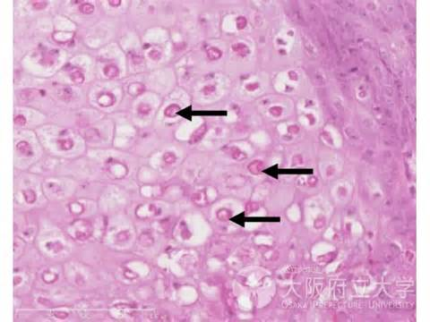
An interesting factoid about the Pox Virus is that it is the only virus big enough to be seen under the light microscope (see photo). All other viruses are so small that they can only be seen by an electron microscope. Eventually the body will make an immune response against the virus and the lesions will go away. This can take several years, however. In the meantime, the lesions can multiply and spread to other parts of the body or other people. When there are more than a few lesions, I usually recommend treating the lesions to help them go away. In the office I typically use Cantharone, which is a topical skin irritant that is applied directly to the bumps with a toothpick. After several hours, the Cantharone causes blistering of the skin. Over the course of a week or so, the blisters will scab and the lesions will go away. Since there may be new lesions forming in the skin, it may take several visits every 2 weeks to “catch up” with new emerging papules and get a handle on the infection. Sometimes liquid nitrogen can be applied. However this burns a bit while the Cantharone does not.
There are several “home remedies” for Molluscum that can be quite effective. Tea tree oil or apple cider vinegar can be applied topically with some success. Also OTC wart medicines such as Compound-W, etc. are similar to Cantharone but not as strong. These can be applied to the lesions at bedtime for 2-3 nights in a row to achieve a similar effect as Cantharone.
Occasionally, a child will present with hundreds of papules or will keep on getting new papules despite recurrent treatment with Cantharone or OTC treatments. On these occasions, I may recommend a course of Cimetidine. Cimetidine (generic for Tagamet) is a stomach acid blocking medication that has been out for over 20 years. It has been available OTC for more than 10 years. For reasons that are not well understood, taking Cimetidine MAY cause Molluscum lesions (and sometimes common warts) to go away. Since there are really no significant side effects from this medication, I occasionally will recommend a 1-2 month course of the drug for more resistant or challenging cases of Molluscum.
Instructions for post-Cantharone care:
Cantharone is applied by a doctor directly to Molluscum lesions using a toothpick. Usually the Cantharone is left on for 4-6 hours and then washed off. If your child complains of stinging after a few hours, you may wash the skin with soap and water sooner than that. Small blisters will develop where the treatment was applied over the first day or so. The blisters will scab and resolve over about a week to 10 days. Some children’s skin is more sensitive that others, if your child develops severe stinging with the initial treatment or if large blisters/redness develop, then with subsequent treatment, wash the Cantharone off in 1-2 hours to minimize the amount of irritation.
Remember, it may take several visits to get a handle on Molluscum. Keep checking your child’s skin after bathing every week or so and return if new lesions develop so that they can be treated before they spread further.

--Be Well

Drew Nash

